1. Launch instance
2. Yum install java
3. Yum install git
4. Yum install maven

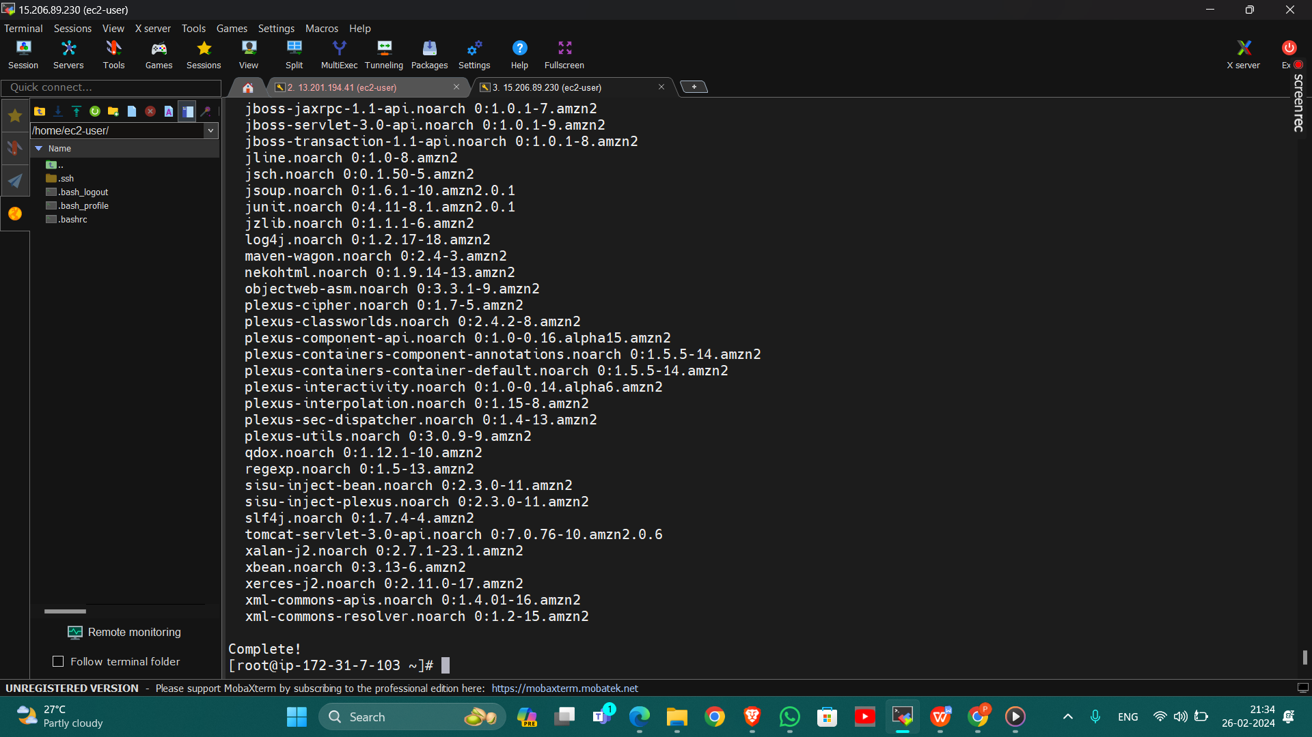

Wget tomcat 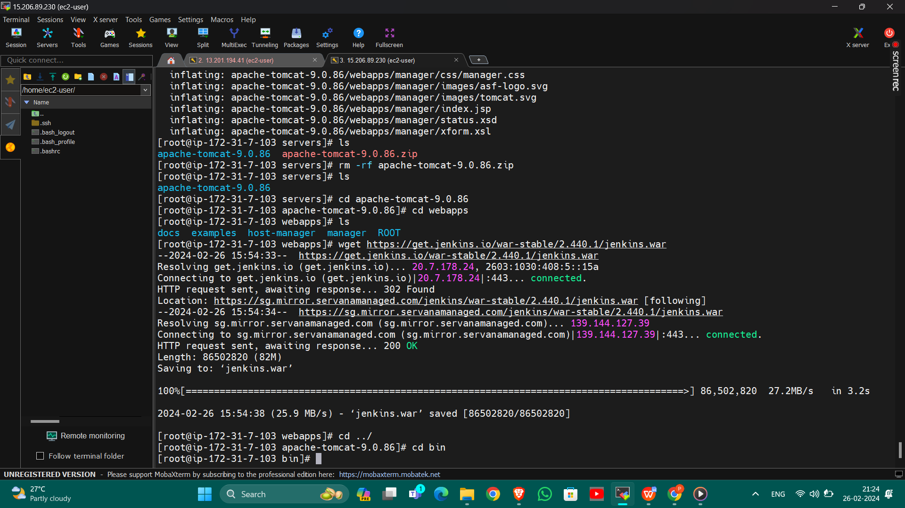

1. Upload the war file

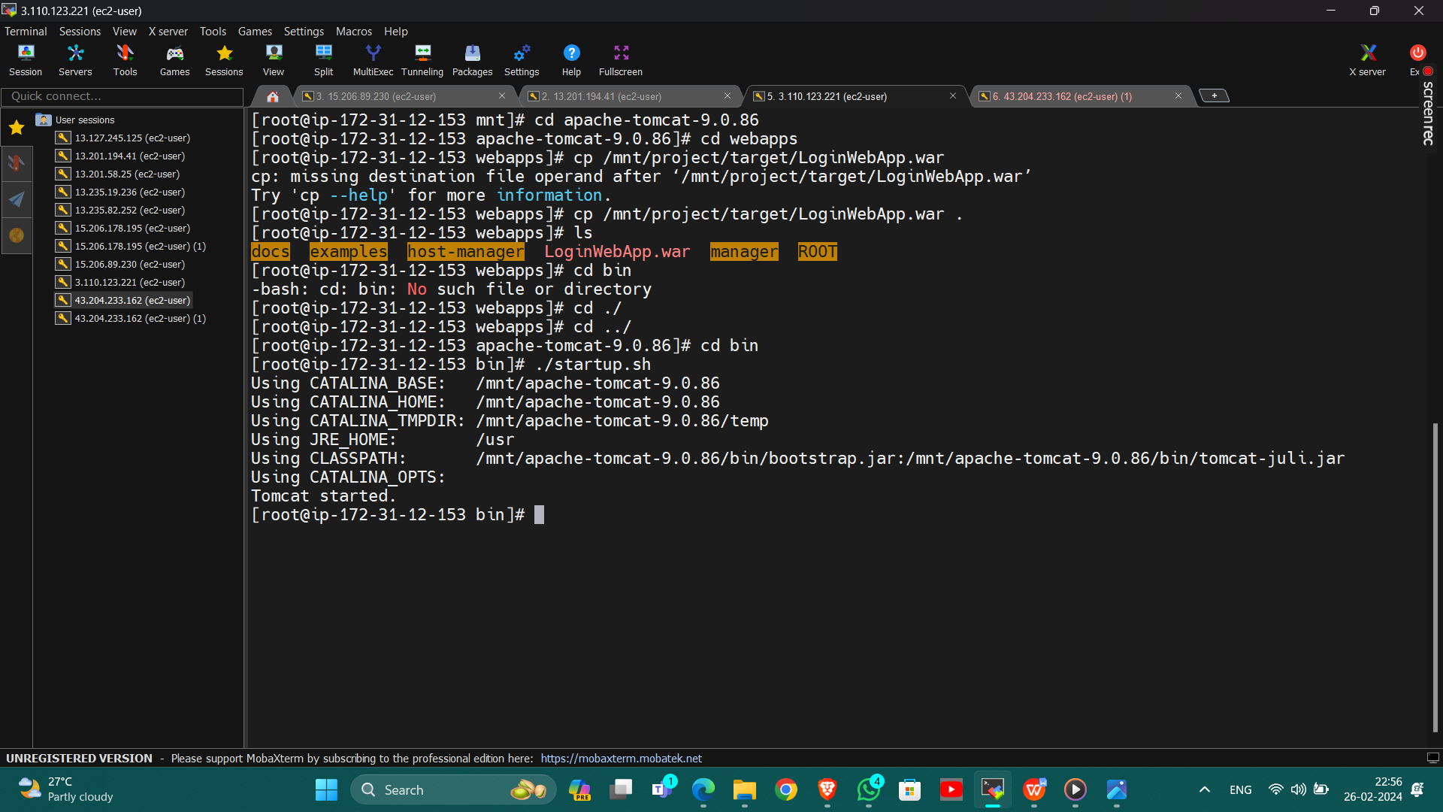

1. Successfully Run
2. 